# GUEST

## Signup - patient

1. Class diagram

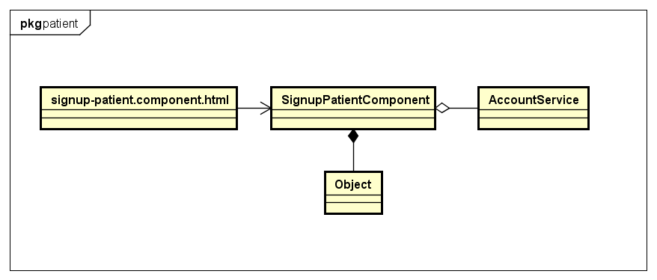

1. Details

* signup-patient.component.html

Refer to UI design

* SignupPatientComponent

|  |  |  |  |
| --- | --- | --- | --- |
| **Attribute** | | | |
| No. | Name | Type | Description |
| 1 | signupForm | FormGroup | Formgroup instance for signup form |
| 2 | submitAttempt | boolean | Check if user click submit button |
| 3 | accountRegisted | boolean | Indicate whether account is registed |
| 4 | signingUp | boolean | Indicate whether system is signing user up |

|  |  |  |  |  |
| --- | --- | --- | --- | --- |
| **Method** | | | | |
| No. | Name | Params | Return type | Description |
| 1 | signUp | data: any,  valid: boolean | boolean | Sign doctor up |

* AccountService

|  |  |  |  |
| --- | --- | --- | --- |
| **Attribute** | | | |
| No. | Name | Type | Description |

|  |  |  |  |  |
| --- | --- | --- | --- | --- |
| **Method** | | | | |
| No. | Name | Params | Return type | Description |
| 1 | signUpPatient | data: any | Observable | Sign patient up |

* Object (Javascipt Object)

## Signup - doctor

1. Class diagram

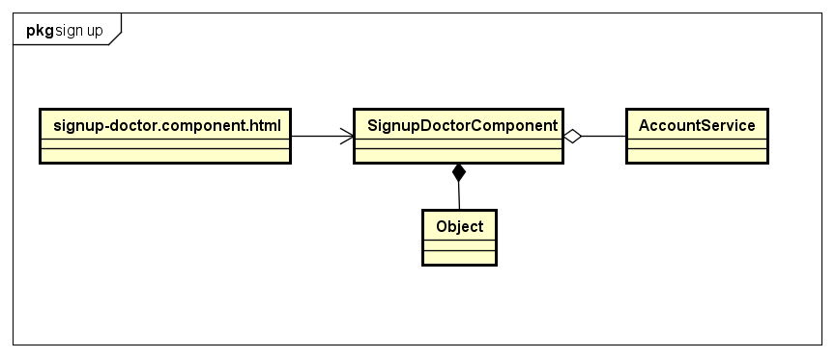

1. Details

* Signup-doctor.component.html

Refer to UI design

* SignupDoctorComponent

|  |  |  |  |
| --- | --- | --- | --- |
| **Attribute** | | | |
| No. | Name | Type | Description |
| 1 | signupForm | FormGroup | Formgroup instance for signup form |
| 2 | submitAttempt | boolean | Check if user click submit button |
| 3 | specialties | Specialty[] | All specialty for doctors |
| 4 | filteredPlaces | Place[] | List of place filter by country name |
| 5 | countries | string[] | List of country |
| 6 | accountRegisted | boolean | Indicate whether account is registed |
| 7 | signingUp | boolean | Indicate whether system is signing user up |

|  |  |  |  |  |
| --- | --- | --- | --- | --- |
| **Method** | | | | |
| No. | Name | Params | Return type | Description |
| 1 | signUp | data: any,  valid: boolean | boolean | Sign doctor up |

* AccountService

|  |  |  |  |
| --- | --- | --- | --- |
| **Attribute** | | | |
| No. | Name | Type | Description |

|  |  |  |  |  |
| --- | --- | --- | --- | --- |
| **Method** | | | | |
| No. | Name | Params | Return type | Description |
| 1 | signUpDoctor | data: any | Observable | Sign doctor up |

* Object (Javascipt Object)

## Search doctors

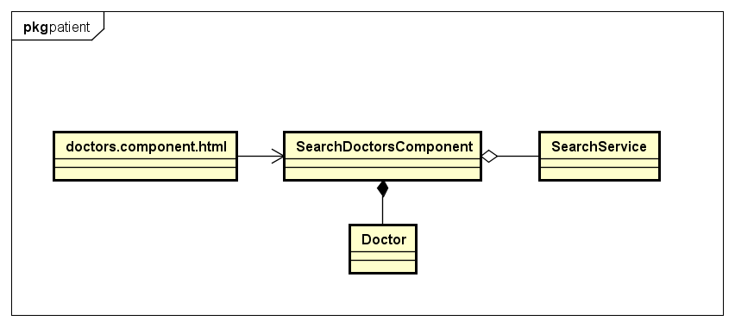

* doctors.component.html

Refer to UI design

* SearchDoctorsComponent

|  |  |  |  |
| --- | --- | --- | --- |
| **Attribute** | | | |
| No. | Name | Type | Description |
| 1 | matchingDoctors | Doctor[] | Store current matching doctors |

|  |  |  |  |  |
| --- | --- | --- | --- | --- |
| **Method** | | | | |
| No. | Name | Params | Return type | Description |
| 1 | searchDoctors | data: any | void | Send request/ Remove request relationship based on context |

* AccountService

|  |  |  |  |
| --- | --- | --- | --- |
| **Attribute** | | | |
| No. | Name | Type | Description |

|  |  |  |  |  |
| --- | --- | --- | --- | --- |
| **Method** | | | | |
| No. | Name | Params | Return type | Description |
| 1 | searchDoctor | name: string,  specialtyID: string,  country: string,  city: string | Observable | Send request get doctors with specific conditions |

* Doctor

|  |  |  |  |
| --- | --- | --- | --- |
| **Attribute** | | | |
| No. | Name | Type | Description |
|  | Id | string | Identify for doctor |
|  | firstName | string | First name of doctor |
|  | lastName | string | Last name of doctor |
|  | fullname | string | Full name of doctor |
|  | email | string | Email of doctor |
|  | password | string | Password of doctor |
|  | dob | string | Day of birth |
|  | sex | number | Sex of doctor |
|  | phone | string | Phone of doctor |
|  | role | number | Role of doctor in system |
|  | status | number | Status of doctor’s account |
|  | address | string | Address of doctor |
|  | photo | string | Photo of doctor |
|  | created | string | Time at doctor account created |
|  | lastModified | string | Last time doctor account is modified |
|  | rank | number | Rank of doctor |
|  | specialty | Specialty | Specialty of doctor |
|  | place | Place | Place where doctor work |
|  | noOfVoters | Number | Number of patient who commented |
|  | attachment | string | Attachment of doctor |

|  |  |  |  |  |
| --- | --- | --- | --- | --- |
| **Method** | | | | |
| No. | Name | Params | Return type | Description |

## View doctor’s profile

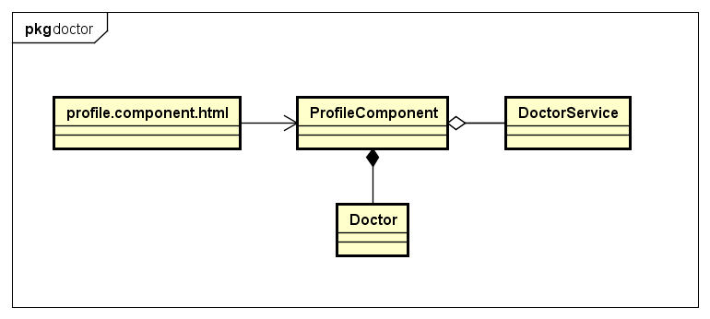

* profile.component.html

Refer to UI design

* ProfileComponent

|  |  |  |  |
| --- | --- | --- | --- |
| **Attribute** | | | |
| No. | Name | Type | Description |
| 1 | doctor | Doctor | Store current doctor profile |

|  |  |  |  |  |
| --- | --- | --- | --- | --- |
| **Method** | | | | |
| No. | Name | Params | Return type | Description |
| 1 | handleDoctorConnection |  | void | Send request/ Remove request relationship based on context |
| 2 | saveComment | data: any | void | Rate a doctor |

* DoctorService

|  |  |  |  |
| --- | --- | --- | --- |
| **Attribute** | | | |
| No. | Name | Type | Description |

|  |  |  |  |  |
| --- | --- | --- | --- | --- |
| **Method** | | | | |
| No. | Name | Params | Return type | Description |
| 1 | getDoctorProfile | account: Account,  doctorID: string | Observable | Send request to update photo |
| 2 | getAllComments | account: Account,  doctorID: string | Observable | Send request to get all comments |
| 3 | deleteReqRelationship | account: Account,  relID: string | Observable | Send request to delete relationship request |
| 4 | sendReqRelationship | account: Account,  doctorID: string,  message: string | Observable | Send request to send relationship request |
| 5 | createComment | account: Account,  data: any, | Observable | Send request to add rating to doctor |

* Doctor

|  |  |  |  |
| --- | --- | --- | --- |
| **Attribute** | | | |
| No. | Name | Type | Description |
|  | Id | string | Identify for doctor |
|  | firstName | string | First name of doctor |
|  | lastName | string | Last name of doctor |
|  | fullname | string | Full name of doctor |
|  | email | string | Email of doctor |
|  | password | string | Password of doctor |
|  | dob | string | Day of birth |
|  | sex | number | Sex of doctor |
|  | phone | string | Phone of doctor |
|  | role | number | Role of doctor in system |
|  | status | number | Status of doctor’s account |
|  | address | string | Address of doctor |
|  | photo | string | Photo of doctor |
|  | created | string | Time at doctor account created |
|  | lastModified | string | Last time doctor account is modified |
|  | rank | number | Rank of doctor |
|  | specialty | Specialty | Specialty of doctor |
|  | place | Place | Place where doctor work |
|  | noOfVoters | Number | Number of patient who commented |
|  | attachment | string | Attachment of doctor |

|  |  |  |  |  |
| --- | --- | --- | --- | --- |
| **Method** | | | | |
| No. | Name | Params | Return type | Description |